Everyone is a winner as PMI Sydney Chapter receives PMI Community Award - “Recognition of Excellence for Member Services”

By Amany Nuseibeh, PMP - Director at Large 

It is with great pleasure and pride, that we share the great news. On 20th October 2012, PMI Sydney Chapter won a Community Award – “Recognition of Excellence for Member Services” at the Awards Ceremony held as part of the Leadership Institute Meeting in Vancouver, British Colombia, Canada.

The PMI Chapter Award for Member Services (PMI Today, November 2012, p14), recognizes chapters that have demonstrated originality in membership program development, which has resulted in attracting new members, raising the retention of members and providing superior member services.

Member Services is one category amongst a number of PMI Community Awards categories that are granted annually.
It was a very proud moment, when Julia Checchia; PMI Sydney Chapter President; accepted the award on behalf of the Chapter. Julia was accompanied by four members of the PMI Sydney Chapter board: Peter O’Driscoll (Vice President), Ha Nguyen (Professional Development), Chris White (Treasurer) and myself (representing both Sydney and Queensland Chapters).

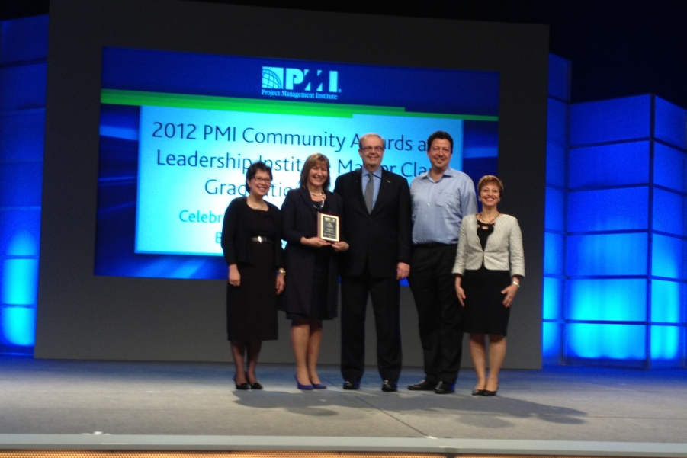

From Left to right: Ha Nguyen (Professional Development), Julia Checchia (President), Peter Monkhouse (PMI Chair), Chris White (Treasurer) and Amany Nuseibeh (Director at Large)

We’d like to thank all of you – our sponsors, our collaboration partners, presenters, members, volunteers and past and present board members, for your great contributions that made this community award achievable and led to this great outcome. Our members’ services are outstanding because of your outstanding involvement, your great contributions, your valued input, your feedback and your on-going engagement. Thank you. Keep it up as we aim to be in the race for more awards next year and the years to come - as we continuously improve our chapter services. We are looking forward to a great 2013, as PMI Sydney Chapter leads the Australian Chapters in organising the inaugural PMI Australian National Conference in May 1st-3rd at Sydney Convention and Exhibition Centres.

For more details about PMI Community Awards, read PMI Today, November 2012 edition.

