
The Sydney Chapter would like to recognise & honour our long standing members on our “Virtual Plaque”.
Each quarter we will award a virtual medal to members who have been part of The Sydney Chapter for 3, 6, 9 or 12 years by adding their name onto the Sydney Chapter Virtual Plaque.

When generating the list I was surprised and excited to see that a large portion of our members have been with the Sydney Chapter for a nine and some for twelve years ! They have no doubt seen the Sydney Chapter evolve into a wonderful community that it is today and it's a tribute to all our volunteers.
Add your virtual award to LinkedIn in the Honors and Awards section and include the respective link to website section where visitors of your LinkedIn profile can find your name.
PMI Sydney Chapter - Platinum Member (12 years)
http://www.pmisydney.org/index.php?option=com_content&view=article&id=331:platinum-members&catid=182:membership-recognision-program&Itemid=211

PMI Sydney Chapter - Gold Member (9 years)
http://www.pmisydney.org/index.php?option=com_content&view=article&id=332:gold-members&catid=182:membership-recognision-program&Itemid=211

PMI Sydney Chapter - Silver Member (6 years)
http://www.pmisydney.org/index.php?option=com_content&view=article&id=333:silver-members&catid=182:membership-recognision-program&Itemid=211
PMI Sydney Chapter - Bronze Member (3 years) http://www.pmisydney.org/index.php?option=com_content&view=article&id=334:bronze-members&catid=182:membership-recognision-program&Itemid=211
For Example

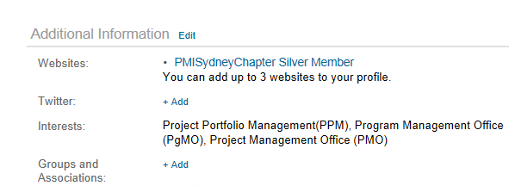

Thank you!
Venesa Lalic (Membership Director)

