Dec Newsletter Feedback:
Page | Section/article | Needs fixing | Change to
Front Page |  | Missing? | Please create a front page..
1 | Table of contents | The Directors Note | Can we change to something like “From the Directors”?
Footer | Month, Edition/Issue# | Currently reads Aug 13 and please check that Issue and edition # is correct | Needs to read December 2013, and the edition and issue number needs to be aligned to the previous one.. can you please check
2 | From President’s desk | Old article | Please update with the article I’ve loaded today and add Julia’s photo please
3 | Treasurer | Jordon | Jordan
4 | From Marketing Director | Picture missing | Could you please add Vikas’ photo  http://www.pmisydney.org/index.php?option=com_contact&view=contact&id=30%3Avikas-patole-msc-mms-ba-pmp-masc-snr-aimm&catid=12%3Abod&Itemid=69
4 | Blank space |  | Is this reserved for the half page ad?
8 | From Prof Dev Director | Picture missing | Could you please add Ha’s photo  http://www.pmisydney.org/index.php?option=com_contact&view=contact&id=35%3Aha-nguyen&catid=12%3Abod&Itemid=69
8 | Prof Dev Director | Where it says “8 certification preparation classes were delivered …” (3rd paragraph from the bottom) | Can you change to “Nine certification preparation classes were delivered ….”
9 | Prof Dev Director Article – Training Team | Missing volunteer | Can you please add Chi Nguyen to the Training team volunteers
9 | Blank space at the bottom of the page |  | Can we fill it in with a stocking filler?  If you need something, see picture below (1) ….  Or, this:  Has LinkedIn helped you find a role in project management? Do you have any tips to share? And, here is some stats about the most overused LinkedIn Buzzwords.  See photo 2 below and you can add this link http://tinyurl.com/mdehx4e  Or, move Siri’s profile there if my article is too long to fit in with it on one page
12 | As above |  | Just need to be careful that the filler is appropriate given the obituary
19 | Full page ad | I don’t think we have a full page ad for this issue? | We have half page ad and I can’t remember seeing it in the newsletter.. have I missed it?

Stocking filler 1 (for page 9)

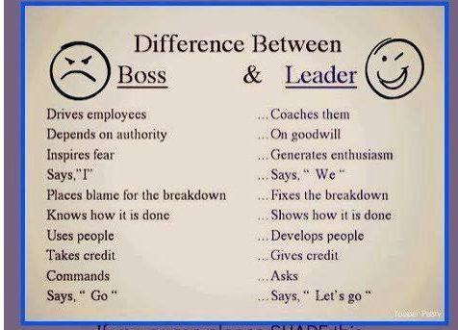
Stocking filler 2 (for page 9)
